Magic Meds
Nestor Vallejos, Steven Hudson, Eduardo Noguera, Dakota Riediger Downing

Dept. of Electrical Engineering and Computer Science, University of Central Florida, Orlando, Florida, 32816-2450

Abstract — This project involves an automatic pill dispenser product. Integrated in it is the selection and construction of hardware components, 3D printing, custom PCB design, and the software engineering of a corresponding mobile application. Both computer and electrical engineering knowledge, fundamentals, and skills were incorporated in the design of the product.
Index Terms — stepper motor, raspberry pi, microcontroller, 3D parts

I. Introduction

Staying on top of everyday tasks and reminders can sometimes be overwhelming and stressful. One of the daily reminders and tasks that many people have to make sure they do every day is taking their vitamins, supplements, or prescriptions. This is especially crucial and important for the elderly community, as they sometimes can forget what medication is needed for certain days. Keeping track of all vitamins, supplements, or prescriptions daily can pose to be a challenge, but with the current technology available, we can make sure that won't be an issue. We want to not only make sure they are reminded of their medications, but that they also have easy accessibility to all medication at all times. In the United States alone, there are approximately 125,000 deaths per year due to medication nonadherence. Although there are several other automatic pill dispensers out there, the automatic pill dispenser in our design is a new and improved way to not only help the elderly community, but for everyone who has the need to take their vitamins, supplements, or prescriptions. However, we are focusing on the elderly community as this product will meet some of the challenges they are faced when having to take their medications. Some challenges the elderly can face with themselves

are dementia, arthritis, paralysis, or any other form of illness that can hinder their physical and mental well-being. Because of those illnesses it can lead to things like forgetting to take medication, having trouble opening the prescription bottles, or forgetting where their prescription bottles are in the first place. With our project we will look to eliminate these challenges and improve the lives of the users. The product will aim to be user friendly and also be a one stop shop for all medication or vitamins. Other current automatic pill dispensers can be expensive or not user friendly which can turn some people away. We want to create a system that is affordable than the alternative current products out there. The system will also include user friendly capabilities and easy to use features that will be more attractive to the elderly community. The elderly will benefit from this product as it will be linked to their current smartphone devices to help with those easy-to-use features. Some of the features on the system will aid and inform the user and their caregiver of when their next scheduled medication is. Not only will the user be notified by reminders, but their caregiver will as well to ensure the user will take their medication. One of the features on the system itself will include an always on display to prompt the user of the date, time, and the next upcoming scheduled medication. The display will have easy and simple to read information that is personal to the user depending on how they configured it. The other feature that will help is having the smartphone linked to the automatic pill dispenser. They will work together to ensure that the user has constant access and reminders to their scheduled medications. Their medication will dispense into a medicine cup once the time is reached to be taken.

A. Goals/Objectives
Our Magic Meds automatic pill dispenser will consist of various components and functionalities. In addition to the physical product itself, there will be a joint smartphone mobile application that the user will be able to use to control the device. The objective of the design is to allow users to self load a weeks worth of medication into the device and schedule the dispense of the medication through the mobile app as well as notify the user of the dispensed medication. If the user has a caregiver, they would also receive notifications. Another goal of the device was to make it as user friendly and affordable to make it marketable and pleasing to customers. Along with this, portability and size was important to consider so it can be easily placed anywhere that is most convenient to the user.

B. Specifications
In table 1 shown below, are some of the specifications that were taken into consideration to ensure the project is up to the standards we set. All parts were selected and made for best results with the device, as well as keeping the costs as low as possible.

1 | Device will have user friendly capabilities and ease of portability.
2 | Communicates constantly with the mobile device app via the internet network using wi-fi.
3 | Device is equipped with a 5.0" 40-pin TFT touchscreen display.
4 | Device parts are 3D printed to have exact measurements.
5 | Users will be able to easily refill medications as needed.
6 | Reminders and notifications will be sent out to both the user and caregiver once medication is dispensed.
Table 1: Engineering Specifications

II. Hardware Overview
The hardware can be broken into two subsystems, the 3D printed components and the electrical components. In figure 1, there is a flowchart on how the hardware overview is laid out within the device. It also shows how the main components are connected within the block diagram.
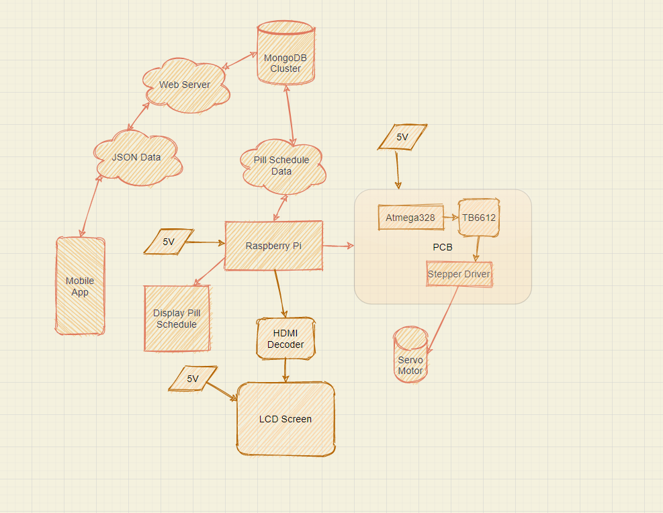
Figure 1: Hardware Block Diagram

A. Electrical Components
The electrical components consist of an 5V 2A power supply, an LCD 800 x 480 touchscreen, an HDMI decoder, a NEMA-14 5V stepper motor, and a PCB, which contains a Atmega328p microcontroller, a TB6612 stepper driver, male and female header pins, and a 16 MHZ clock. The LCD touchscreen is responsible for displaying the medications on a user interface in real time to the users, so they are aware of what medications are being dispensed and at what time. The stepper motor rotates the pill wheel to the next day that needs to dispense pills. Our PCB, most importantly, is responsible for the functionality of the stepper motor through the conversion of microcontroller instructions into the TB6612 stepper driver, which then converts those instructions into analog signals that allow the motor connected to it to rotate. The male and female header pins allow for the signals to be sent between components via jumper wires. The 16 MHZ clock is responsible for sending out the microcontroller signal at the specified frequency (time) in order for the drivers to read the instructions in a timely fashion and rotate the motor at the exact moment it needs to.

B. 3D Printed Components
The actual container itself was designed using Fusion 360. This allowed for complete creative freedom with designing the enclosure. Since none of us had experience in Fusion, this required some learning to create and export the files to .stl for printing. All files were printed using team member Steven Hudson's Ender 3 Pro 3D printer.

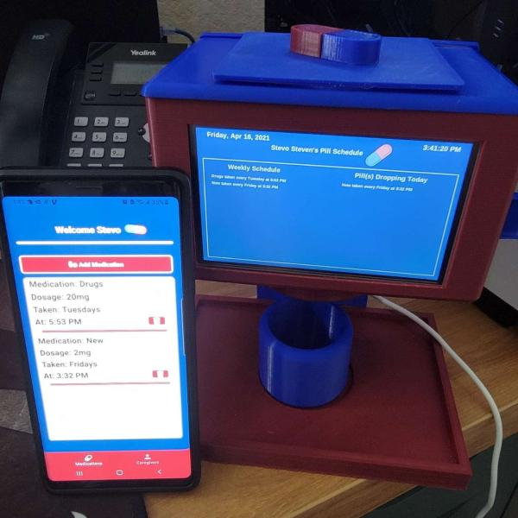
Figure 2: Magic Meds Device

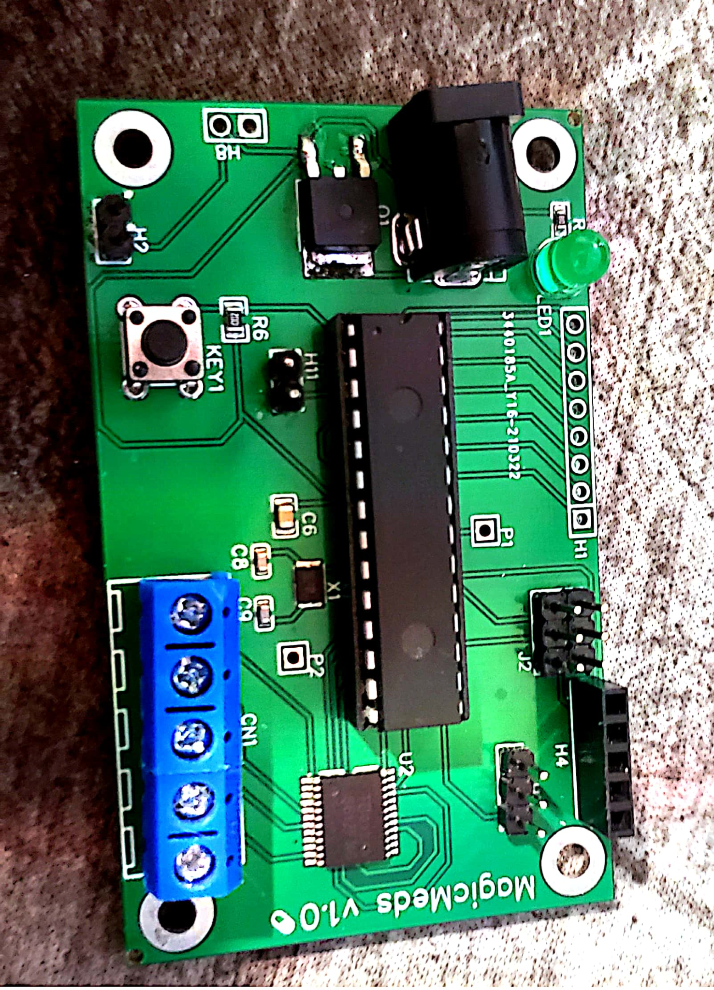
Figure 3: PCB Board

III. Hardware Design

The hardware design can be broken down into multiple subsystems. These include, the Raspberry Pi to the display, the Raspberry Pi to the PCB, the PCB to the stepper motor, the design of the container holding the electrical components, and the pill wheel dispensing mechanism.

A. Raspberry Pi to the Display
The Raspberry Pi communicates to the display via the HDMI decoder which is partnered with a python script running on the Pi itself. The python script runs the GUI that is displayed on the LCD touchscreen. The GUI is connected to a MongoDB database in order to display the specific individuals content that is assigned to their personal product code. The Pi connects to the HDMI decoder via a short HDMI cable. The Pi uses micro HDMI so an adapter was used. The HDMI decoder connects to the LCD screen via a 40 pin ribbon cable. The decoder requires power to run, we are powering the decoder via a 5V pin on the Raspberry Pi, similar to how we power the PCB.

B. Raspberry Pi to the PCB
The Raspberry Pi communicates to the PCB via SPI pins on both the Pi and the PCB through physical wires. With those signals the PCB directs the stepper motor within the machine to spin 1/8th. The PCB is powered via the Pi’s 5V pin.

C. PCB to the Stepper Motor
The PCB and our stepper motor communicate through a microcontroller to perform the necessary tasks. The microcontroller communicates to the stepper driver through the tb6612fng motor driver. . The stepper driver sends analog signals to the motor. Our PCB includes both of these functionalities all in one chip. Powered with a 5V source, the PCB includes the atmega328p microcontroller communicating directly to the TB6612 stepper driver through its input pins and from there the TB6612 stepper driver sends signals to a wire terminal block, which lastly through jumper wires, sends the signal to the motor.

D. Power Supply
The obvious most power hungry piece of hardware here is the Pi, the Pi uses a 5V 3A power supply, but we found that 5V 2A power supplies worked well also since we are not pushing the limits of the Pi by any means.The current power system is as follows, a 5V 2A usb-c cable connect to a usb-c power switch that plugs into the Pi. The Pi then powers the HDMI decoder and the PCB via the two 5V pins located on the Pi’s GPIO. A future improvement we could implement is using a lower power Pi, like the Pi Zero W. This would allow us to not only use less power, but route the power elsewhere first, so instead of the Pi powering the other components, we could use the PCB to power the other components.

E. 3D Container Design
The design of the container was simple. We created a hollowed rectangular prism, so that all the electrical components could fit into it. The rectangular prism also had a rectangular cut on one of the sides to allow the LCD touchscreen display to be visible for the users use. The cap was created to create ceiling space for the electrical components and the cylindrical pill holder. Connected to the cap, the servo motor rests on the snap lid and the pill holder is connected to that to spin freely. The design of the pill holder is simple.

F. Pill Wheel Dispensing Mechanisms
The pill holder has 8 slots, one for every day of the week, and one dummy slot to start the week off on. The reason for the dummy slot is so that the pills can be dispensed on rotation versus by encapsulation. The pill holder on the bottom side has a free spinning disk with pill holder like cut into it, so that every time the holder rotates because it is dispensing, it will have an opening on the bottom half at the day and drop the pills into a funnel blow. The funnel is a basic funnel which is at the bottom of the rectangular prism container. The pills then funnel into a cup. Along, the inside of the container are walls preventing the pills from falling into the electronics portion of our device.

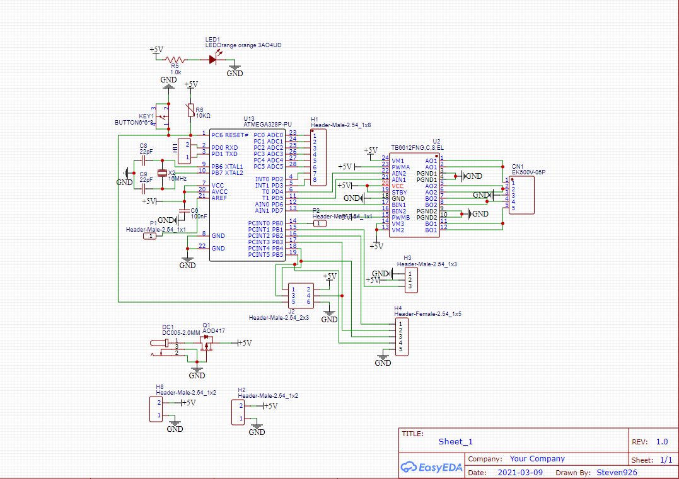
Figure 4: PCB Schematic

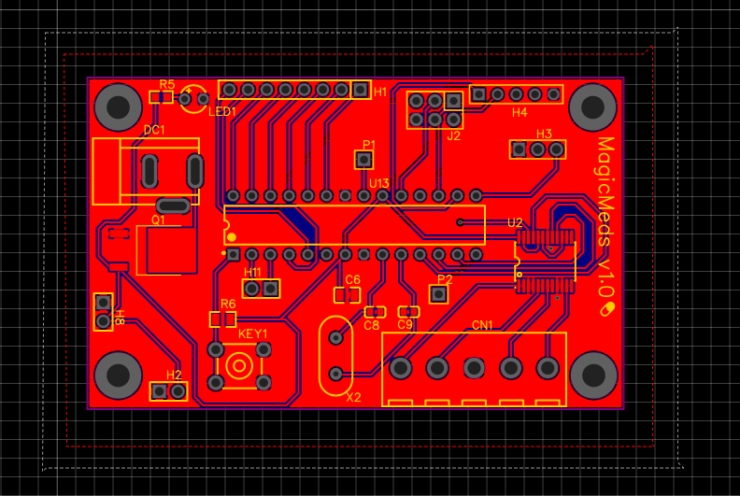
Figure 5: PCB Layout

IV. Project Software Design
The software portion of this project was a large portion of the project as a whole and is broken down into four different components, the mobile app, the raspberry pi code, the caregiver website, and the microcontroller code. All code was version controlled using GitHub.
A. Mobile Application
The primary goal of the mobile application is to schedule pills to be dispensed and add caregivers to receive text notifications as well as notify the user with app based notifications. The mobile application integrates all the “run of the mill” functionality of account based applications and aims to be as simplistic as possible with a bottom navigation bar interface and modal pop ups for filling out forms. It aims to be as user friendly as possible as this app could easily fall in the hands of the older generations who are just recently adjusting to smartphones.
The app is built on a MERN stack. This is MongoDB, Expres, React Native, and Node. This was a clear choice, with limited time on the teams hands, this solution offered a single code base with easy native code translation. By using Expo, we eliminated any need for purely android based or ios based code and were able to write the entire mobile app in JavaScript. Along with this, Expo offered great documentation on how to handle notifications for the app making it an easy feature to implement. For hosting, we used Heroku’s hobby tier for $7 a month that allowed our application to be constantly loaded on Herokus servers and ready to be used. Initially, we used Herokus free tier, however the free tier unloads your application after some time of no use, this meant that everytime we attempted to test the app, the initial API call would take 30 seconds to a minute. This would cause errors if the user was already logged in and the app was attempting to make API calls to receive the users medications. Our MongoDB cluster was hosted by Mongo Atlas using their free hosting service through AWS.
The mobile application can be broken into three UI components along with a backend server. The three UI components are the login page, the medications page, and the caregivers page.
The login page is a very basic login page with two options, login and sign up. No forgotten password functionality was built out. The login area takes a username and password and attempts to sign in the user through an API call. The sign up button opens a modal for the user to fill out a form to sign up for an account. The sign up requires the users basic information: first name, last name, username, password, email, and product code. The product code is used to connect the users account with the pill device. This product code is the ID of the device hard coded into the python of the pill machine itself. This allows the device to get the users pill schedule and read the users data from the database.
Once past the login screen the user is met with a bottom navigation bar that has two page options, “Medications” and “Caregivers”. On the Medications page the user has the option to add medications and delete medications. Adding a medication requires the user enter a medication name, a dosage, a day of the week the pill is taken, and a time the pill is taken. When the user clicks to save the pill information the app checks to make sure that there are no other pills scheduled for that day at a different time. This check is necessary since our device only performs one pill drop per day, so any pill added for the same day must be added for the same time. If the pill violates this check, then the app tells the user there is a time mismatch and the user must add the pill for the same time as the other, or delete the other pill from the schedule. Once a pill is successfully added the user will receive an app notification when the pill has dispensed with the details of the pill(s). The user can delete the pill by pressing the button with a trash can icon. This brings up a “soft stop” modal that lists the details of the pill and asks the user if they are sure they want to delete it. If they select “yes” the pill is deleted from the database permanently. No bit flags are used.
The other page in the navigation bar and final UI components is the caregivers section. The caregiver functionality was made as an accountability tool. Caregivers would receive texts when the users pills dispense and they could follow up with the user to ensure they took their medication. The layout is very similar to the medications section except here you have a sign out option to sign out of the app. Here users can add and delete caregivers, similar to adding medications, that will receive text messages when the pills dispense for the user with the details of the pill(s) that dropped. This SMS feature is done by integrating Twilio’s SMS service into the app. A user can only add a caregiver if they have signed on to be a caregiver in the database via the caregiver website. This is to stay in line with FCC rules on SMS messages. This ensures a user cannot add just anyone to the app and have that person start receiving SMS messages. If a user attempts to add a caregiver who has not signed up, they will receive a “hard stop” in the app stating that the caregiver does not exist and they need to sign up on the website first.
The app also takes advantage of AsyncStorage to ensure that if the user has already signed into the app and has not signed out, the next time they open the app they will load right into their account, no sign in is necessary.
Outside of the UI components we have an in depth API that handles the communication between the app and the database. Notable API functionality includes logging in, getting medications, getting caregivers, deleting, and signing out. Outside of this we have a job that runs every five seconds checking to see if the current time matches the time of any of the medications in the database. If the times do match, the job queries for the user it belongs to, as well as their caregivers and sends out notifications and text messages as necessary with the details of the medication(s).

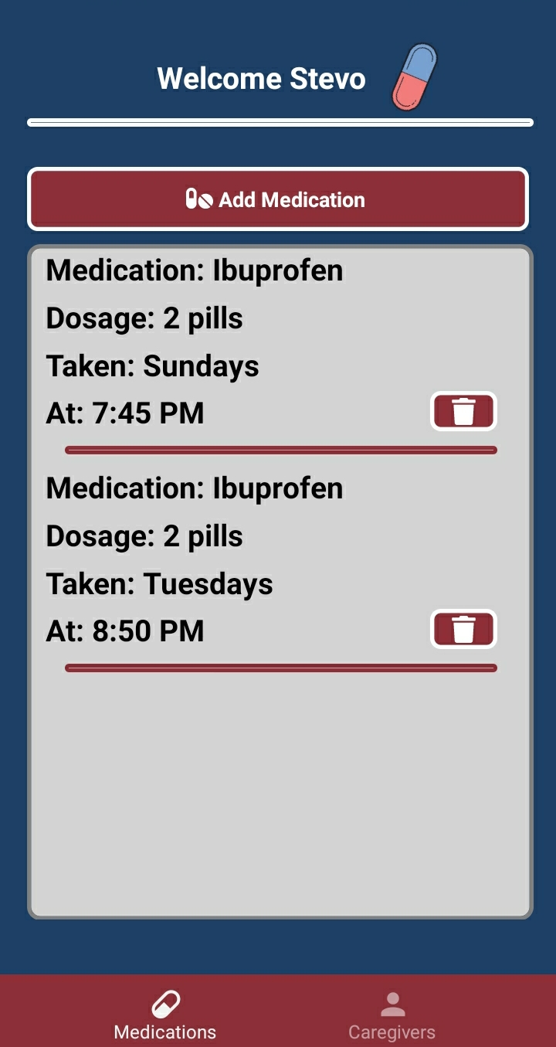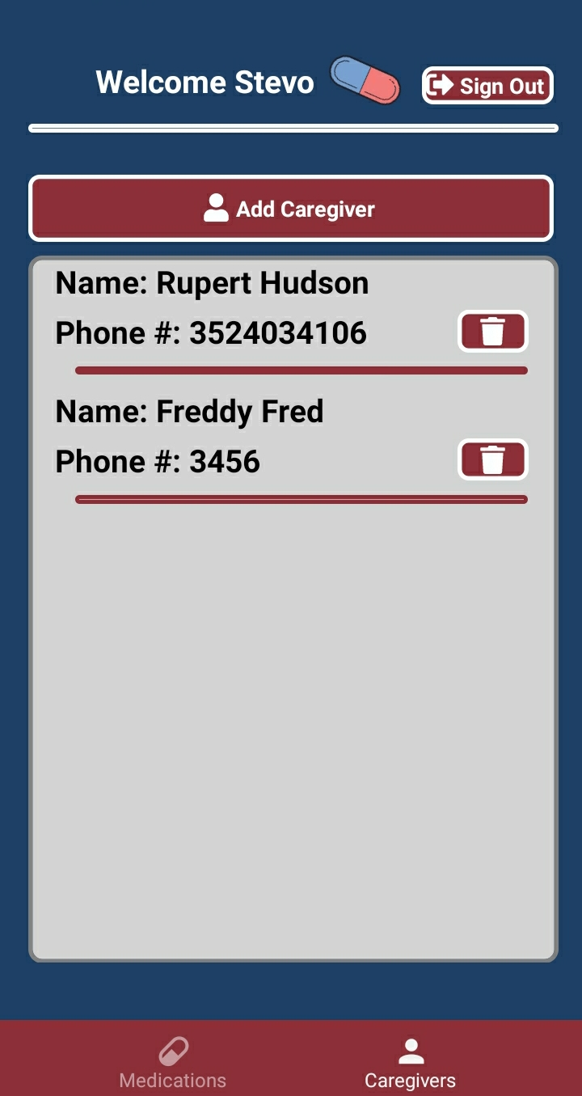
Figure 6: Mobile Application UI

B. Caregiver Website
The goal of the caregiver website was to have a place where caregivers could go and sign up to be added to the caregiver cluster of the database. This way a user could add them as a caregiver to the mobile app and they could start receiving texts when the users pills drop to follow up and ensure they took their medication.
The caregiver site is also hosted by Heroku, but it is under the free tier so it takes approximately 30 seconds to 1 minute to load the site. The site has a basic UI that asks for a first name, last name, and a phone number as plain text. Once filled out the caregiver selects the add button to place themselves in the caregiver database. If the user has already signed up then they receive a message that they have already signed up, otherwise they receive a success message. The site can be found at this link: https://magicmedscaregiverportal.herokuapp.com/
C. Raspberry Pi
The Raspberry Pi was mainly utilized as a way to program the user interface on the touchscreen as well as a way to establish a wireless connection to our database. The code on the Pi was written using Python and is made up of three components: A GUI, an API, and a job scheduler. Through some file manipulation we were able to set up the Pi to run the GUI and job scheduler at startup.
The main focus of the GUI was to create a space where the user can see the upcoming pills on the device itself. Initially, the GUI was touchscreen enabled and would check to ensure a user had signed up before moving them to the main schedule screen. If the user had not signed up for an account on the mobile app yet, the GUI would instruct them to first then come back. This way the product code would be linked to retrieve the users schedule. If the user was signed up, then they would be welcomed and would touch the continue button to bring up the main schedule screen. Sadly, the touch functionality seemed to fail on the screen close to the due date. With no time to order a new screen, we had to scrap it and move forward with just the main schedule screen. The main screen includes the user's name, the date, the time, their entire weekly pill schedule, and their pills dropping for the current day. The GUI was made using Python's Tkinter GUI library and updates as a loop using the API which grabs data from our MongoDB collection. This way if a medication is added to the app while the machine is on, it updates on the GUI in real time.
The job scheduler is a Python script that runs a job every second. The job uses the API to check medication times in the database for the user the product code is assigned to and check them against the system's current time. If the current time does not match, nothing happens, however if the current time does match, then a signal is sent over the SPI pins on the Pi to the SPI pins on our PCB. This signal tells the Atmega328p it needs to spin the stepper motor and the Atmega communicates this to the tb6612fng motor driver which then drives the stepper 1/8th of a step, dropping the pills into the funnel, then into the cup below.
The API is shared among the GUI and the job scheduler as a way to get the data in the database relating to the user with the product code that is hard coded into the API.
D. Microcontroller
The microcontroller was programmed via Arduino’s IDE and through the use of the atmega’s bootloader. This involved first flashing the Atmega328p bootloader using an Arduino Uno, then using an ICSP to program the Atmega328p with the code. In the code, the microcontroller is instructed to rotate the stepper motor 1/8th of a full rotation when a byte is received from the Pi.
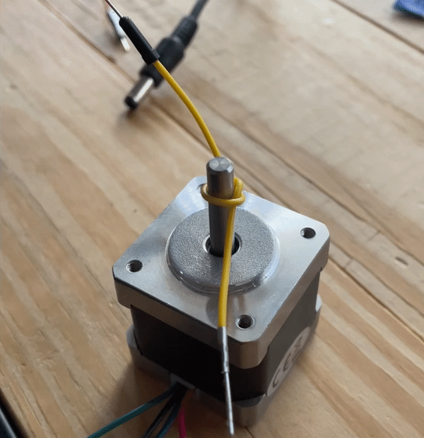
Figure 7: Stepper Motor Rotating

V. Design Struggles
Starting with the hardware, our touchscreen stopped working with little time left, so we had to adapt the GUI code to not use the touchscreen functionality. With our software, we had struggles with keeping the state of the mobile app correct. This meant that if a user were to sign out of one account and login with a new account, the user would see all the data of the last account. You’ll also notice in our demo that when the in app notifications come through, it sends multiple of the same notification. This was due to a bug where the app sends a notification everytime the state of the app updates.
VI. Conclusion
The purpose of the Magic Meds: Automatic Pill dispenser was designed to be an affordable device that is simple and gives peace of mind to people who take daily medications. Each user has a user friendly mobile application that allows them to connect to the device and add what medications they need to take with reminders and notifications to let them know when their medication is ready to be taken. With an always on LCD display, the user can always check in with the device to see when their next medication is set to be taken.
With an overall design consisting of a raspberry pi 4 communicating with the ATMEGA328p microcontroller on the PCB, that sends signals to the motor to spin, it allows for simple yet efficient communications. This will allow for many devices to be made for rapid production while also keeping costs low.
Planning and designing the Magic Meds: Automatic Pill Dispenser has been a challenge but rewarding experience. Due to Covid-19, accessing labs was limited, but has helped us compromise and have all the tools we need. This has helped us come together as a team and also incorporate the skills and knowledge we have learned in studying Computer and Electrical Engineering.

VII. Administrative Content
For the budget of our project, we tried to set the budget at $500 or less due to the project being funded by our own wallets. We ended up finishing under budget at $246. This does not take into account the $7 monthly fee for hosting the mobile app on Heroku.

Acknowledgement
The authors would like to acknowledge the assistance, support, and guidance of Dr. Samuel Richie and Dr. Lei Wei over the course of Senior Design I/II.

We would also like to thank the committee members for taking the time to be a part of our project and being understanding during these unprecedented times.

References
[1] “From Arduino to a Microcontroller on a Breadboard.” Arduino, 5 Feb. 2018, www.arduino.cc/en/Tutorial/BuiltInExamples/ArduinoToBreadboard.
[2] Industries, Adafruit. “Stepper Motor - NEMA-17.” Adafruit Industries Blog RSS, www.adafruit.com/product/324.
[3] Foundation, Raspberry Pi. ​Buy a Raspberry Pi 4 Model B – Raspberry Pi​, 2012, www.raspberrypi.org/products/raspberry-pi-4-model-b/.
[4] Pcb basics. (n.d.). Retrieved April 21, 2021, from https://learn.sparkfun.com/tutorials/pcb-basics/a]]\

Biography

Nestor Vallejos
Computer Engineering

Nestor Vallejos is a first generation graduating Computer Engineering major from the University of Central Florida. Over the summer of 2020 he interned for American Express as a Software Engineer Intern and has accepted a position as a Software Engineer for American Express starting in August 2021.


Steven Hudson
(Computer Engineering)

Steven Hudson is a graduating Computer Engineering major from the University of Central Florida. He has accepted a full time position as a Software Tester and Developer at TheraPlan.


Eduardo Noguera
(Computer Engineering)

Eduardo Noguera is a graduating Computer Engineering major from the University of Central Florida. In summer of 2020, he interned as a Software Engineer for JP Morgan Chase & Co. He has accepted a returning offer for JP Morgan Chase and will be joining them in Fall 2021.



Dakota Riediger Downing
(Computer Engineering)

Dakota Riediger Downing is a first generation graduating student with a degree in Computer Engineering from the University of Central Florida. He is actively looking for a full-time job.

